STUDENT INNOVATORS SHINE AT SCIENCE AND TECHNOLOGY SHOWCASE
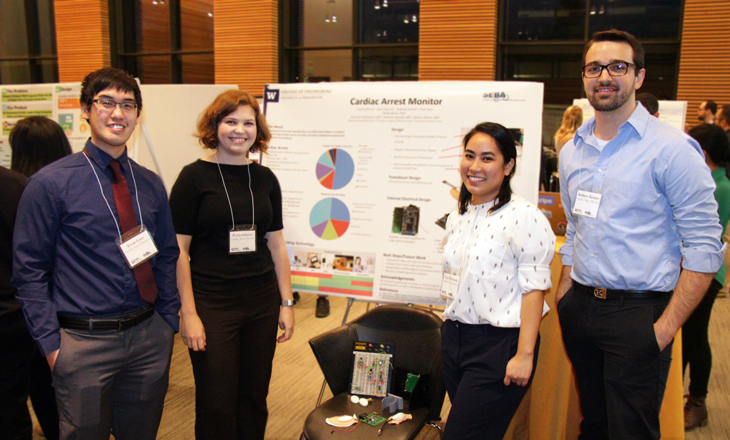
Grand Prize Winners Cardiac Arrest Monitor (from Left to Right): Evan Lam, CEO Paula Gibson, Lyra Hancock, Andrew Kessler
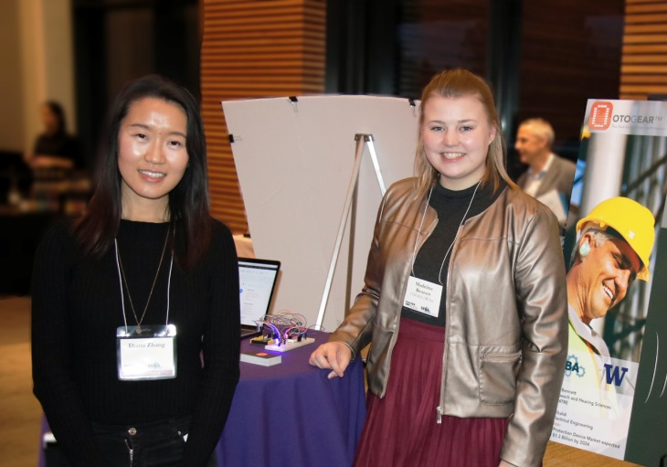
Seven student teams took home prizes at the 12th Annual Science and Technology Showcase (STS) at the University of Washington. Grand Prize sponsor Magic AI presented $1,000 to a team of engineering students for their innovative approach to providing real-time data on blood flow fluctuation in a patient experiencing cardiac arrest. A complete list of the winning teams is detailed below.
The STS is co-hosted by the UW Foster School’s Buerk Center for Entrepreneurship and the Science and Engineering Business Association (SEBA) student club. This year’s competition featured nineteen teams from colleges and schools across campus. The showcase provides University of Washington students with the opportunity to pitch the commercial potential of their science- and technology-based innovations. Seattle-area entrepreneurs and investors served as judges and also provided in-person feedback and mentorship.
The event preceded a team formation event featuring students of all disciplines looking to recruit members to their startup team, or join one. Many of the STS competitors and the teams formed at the event are expected to compete in upcoming competitions from the Buerk Center including the Hollomon Health Innovation Challenge (March 1), the Alaska Airlines Environmental Innovation Challenge (March 29), and the UW Business Plan Competition (Investment Round April 25).
Second Place Prize and Best Marketing Strategy winner. OTOGEAR CEO Madeline Bennett (Right), shares a photo with student volunteer Diana Zhang (Left)
The Buerk Center and SEBA wish to thank all of this year’s sponsors: Magic AI, Arivale, Davis Wright Tremaine LLP, and the WRF Capital.
Congratulations to this year’s STS award winners:
$1,000 MAGIC AI GRAND PRIZE: CARDIAC ARREST MONITOR  CARDIAC ARREST MONITOR | CARDIAC ARREST MONITOR helps emergency department personnel better perform resuscitation of patients experiencing cardiac arrest. The technology identifies and monitors in real-time the fluctuation of a patient’s blood flow.
$500 ARIVALE SECOND PRIZE: OTOGEAR  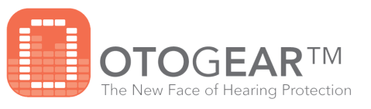 | OTOGEAR uses hearing protection technology to reduce or eliminate dangerous noise levels in the workplace, while also alerting employees to the sound levels at a job site upon entrance.
$300 WRF CAPITAL THIRD PRIZE:  4TH-PHASE  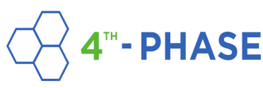 | 4TH-PHASE seeks to solve the problem of high-operational expenses for indoor famers looking to address the global food crisis. 4TH-PHASE technology maximizes the ability of water to fuel plant growth while improving crop yield without additional resources.
$100 DAVIS WRIGHT TREMAINE MOST INNOVATIVE AWARD: OLICO | OLICO developed a platform for designing protein-based therapeutics to treat cancer and other diseases. The technology represents an opportunity to engineer “the next generation of biologics.”
$100 DAVIS WRIGHT TREMAINE BEST COMMUNICATOR AWARD: GLIMPSE WEARABLES  GLIMPSE WEARABLES | GLIMPSE WEARABLES is developing smart-glasses and wearable-camera technology to give users a way to avoid the distraction of looking down at smartphones while things happening in front of them.
$100 DAVIS WRIGHT TREMAINE BEST  MARKETING STRATEGY AWARD: OTOGEAR | OTOGEAR uses hearing protection technology to reduce or eliminate dangerous noise levels in the workplace, while also alerting employees to the sound levels at a job site upon entrance.
$100 DAVIS WRIGHT TREMAINE MOST ENTHUSIASM AWARD: GRADSTRY  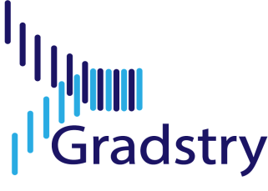 | GRADSTRY connects businesses seeking talent for short-term projects with qualified graduate students. The user-friendly online talent portal provides users an easier way to comb through applicant data and match them with the right project.
$100 DAVIS WRIGHT TREMAINE BEST POSTER  AWARD: MAPSENGER | MAPSENGER developed a map-based real-time messaging application that allows users to discuss, search, and share places to meet among a group of nearby friends.

